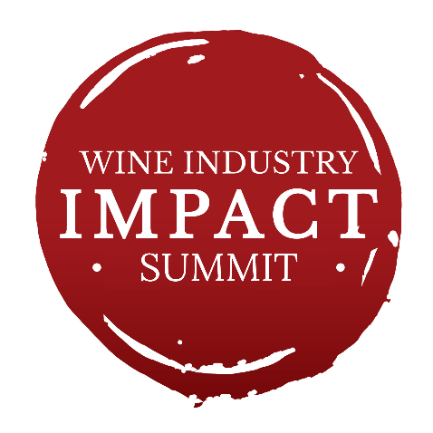
WINE INDUSTRY IMPACT SUMMIT 2026
Real challenges. Real solutions. Real proof they work.

Thursday 13 August 2026 · National Wine Centre, Adelaide · 9:00am–5:00pm

PRESENTED BY WISA, WITH THANKS TO PRESENTING PARTNER, WINE AUSTRALIA

WITH THANKS TO OUR EVENT SPONSORS
 | 
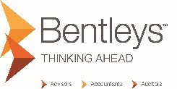 | 
Supporting Partners: Amorim, Innovint

PROGRAM
TIME | SESSION | SPEAKERS & PRESENTERS
9:00am | Summit Opening & Welcome | Liz Schoen — Executive Chair, Wine Industry Suppliers Association
9:10am – 9:50am | PANEL: Innovation That Is Delivering Results & the Power of Partnerships  Sponsored by MGA Insurance Group  Leaning in during difficult times — listen, share, connect. The panellists in this session have identified a real industry problem and built something that solves it. They share the innovation journey, because the story of how an idea becomes industry impact is what delegates learn from most. | Moderator: TBC  Panellists: Heather Mackenzie, Affinity; Eveline Bartowsky, Lallemand; Rocco, Enartis–WineGrid
9:50 – 10:20am | CASE STUDY · VITICULTURE  Autonomous Spraying in the Vineyard: The Research–Supplier–Grower Story  Fifty hectares sprayed autonomously in a first full season. This session brings the researcher, supplier and grower behind the GOtrack project at Vinarchy together to show what genuine three-way collaboration delivers in practice. | Tim McCarthy, Vinarchy; Caitlin Davies, AWRI; Cam Clifford, Agri Automation Australia
Morning Tea · 10:20 – 10:50am
10:50 – 11:20am | CASE STUDY: PACKAGING  Sustainability in Packaging  Sponsored by Visy  A redesigned Riesling bottle, a producer–supplier partnership, and a glimpse of what’s possible when the two work together early. See how rethinking a “solved” format unlocked new efficiencies, cost savings and market opportunities — and what it means for producers ready to partner differently with their suppliers. | Gavin Wong, Visy; Carmen Housten, SIG; Wirra Wirra , Matt Deller
11:20am – 12:00pm | CASE STUDY: GRAPEGROWING · INCLUDES TASTING  Next Generation Vines: Breeding for the Future  How cutting-edge vine breeding and varietal research is shaping the varieties and growing systems that will sustain the Australian wine industry over the coming decades. | Sharon Harvey, Wine Australia; Cath Kidman / Ben Harris, Treasury Wine Estates; Cindy Heley, Monach Wines; Nick Dry
12:00 – 12:40pm | PANEL: Built to Last: Risk, Resilience & the Conditions for Growth  Sponsored by Bentleys  For wine businesses that are looking forward, not just getting through. This session covers cyber and operational risk, cash flow as the engine of innovation, export market exposure, and what it means to structure a business for sustainable growth. | Speaker MGA Insurance Group;  James Allen, Bentleys
Lunch · 12:40 – 1:30pm
1:30 – 2:00pm | CASE STUDY: WINERY SYSTEMS  Winery Operating Systems in Action  Supporting sponsor: Innovint  A practical look at how modern winery management platforms are transforming operations — from production planning and inventory to compliance, traceability and reporting. | Paul Jackson, Innovint;  Jason Spiteri, HSFE
2:00 – 3:00pm | Balancing Innovation and Risk in the Age of AI  How leaders can implement AI with confidence while managing the real risks around privacy, governance and responsible use — and what that looks like in practice for the wine industry. | Eloise Leaver, National AI Centre; Darren Oemke, Hydra Consulting
Afternoon Tea · 3:00 – 3:30pm
3:30 – 4:30pm | PANEL: Best Practice Innovation Management  Session sponsor: Adelaide University  From insight to impact — how do we get research into the hands of industry? This session examines innovation pathways: internal R&D versus external partnerships, aligning goals across research, supply chain and industry, and what best-practice innovation management looks like in the wine sector. | Moderator: Josh Hixon, Wine Australia  Panellists: Caitlin Davies, AWRI;  Tim Stead, Amorim;  Rebecca Dolan, Adelaide University  Winery TBC (Brown Brothers?)
4:30 – 5:00pm | Moderated Session: What Does Collaboration Actually Look Like?  The summit closes with a structured, facilitated session — three tracks, 150 voices, one question: what would it take for research, suppliers and industry to work together differently? The output will inform the WISA Wine Value Chain Report. | Facilitator (TBC) · interactive session using Slido
Program correct at time of publication. Sessions, sponsors and speakers marked TBC are subject to confirmation and may change.

